Project Planning Phase
Project Planning Template (Product Backlog, Sprint Planning, Stories, Story points)

Date | 8 March 2026
Team ID | 699d5fd13074df695bbbb146
Project Name | AI-Powered Customer Support & Service Automation
Maximum Marks | 8 Marks

Product Backlog, Sprint Schedule, and Estimation (4 Marks)
1. Product Backlog, Sprint Schedule and Estimation

Sprint | Functional Requirement (Epic) | User Story Number | User Story / Task | Story Points | Priority
Sprint-1 | Customer Management | US-1 | As an admin, I can create and manage customer records. | 3 | High
Sprint-1 | Product Management | US-2 | As an admin, I can add and manage product details. | 2 | High
Sprint-1 | Order Management | US-3 | As a user, I can track customer orders. | 3 | High
Sprint-2 | Case Management | US-4 | As a support agent, I can create customer support cases. | 3 | High
Sprint-2 | Case Routing | US-5 | As a system, I automatically assign cases to queues. | 2 | High
Sprint-2 | Validation Rules | US-6 | As an admin, I can enforce data validation rules for cases. | 2 | Medium
Sprint-3 | Automation Flow | US-7 | As a system, I automatically send reminders for unresolved cases. | 3 | High
Sprint-3 | Approval Process | US-8 | As a manager, I can approve or reject critical cases. | 2 | High
Sprint-4 | AI Integration | US-9 | As a support agent, I receive AI-generated case summaries. | 3 | High
Sprint-4 | Reporting | US-10 | As a manager, I can view reports and dashboards for case insights. | 2 | Medium

2. Project Tracker (Sprint Planning)
Sprint | Total Story Points | Duration | Sprint Start Date | Sprint End Date (Planned) | Story Points Completed | Sprint Release Date (Actual)
Sprint-1 | 20 | 2 Days | 02 Mar 2026 | 03 Mar 2026 | 20 | 03 Mar 2026
Sprint-2 | 20 | 2 Days | 04 Mar 2026 | 05 Mar 2026 | 20 | 05 Mar 2026
Sprint-3 | 20 | 2 Days | 06 Mar 2026 | 07 Mar 2026 | 18 | 07 Mar 2026
Sprint-4 | 20 | 1 Day | 08 Mar 2026 | 08 Mar 2026 | 20 | 08 Mar 2026

3. Velocity Calculation
Velocity is a measure used in Agile project management to determine the amount of work a team can complete during a sprint. It helps teams estimate how much work can be handled in future sprints and improves sprint planning accuracy.
In this project, the development work was completed between 2 March 2026 and 8 March 2026. The project was divided into four sprints, and each sprint was assigned an estimated 20 story points.
Velocity Calculation
- Total Story Points per Sprint = 20
- Sprint Duration = 10 days (example estimation model used in template)
Formula:
$$AV=\frac{Velocity}{Sprint Duration} \\ AV=\frac{20}{10} \\ AV=2$$
Result
The Average Velocity (AV) = 2 story points per day.
Interpretation
This means the development team can complete approximately 2 story points per day during a sprint. This velocity helps the team estimate the workload and plan future iterations effectively.
Velocity tracking also helps in:
- Monitoring team productivity
- Predicting sprint completion
- Improving sprint planning
- Ensuring balanced workload distribution

4. Burndown Chart Explanation
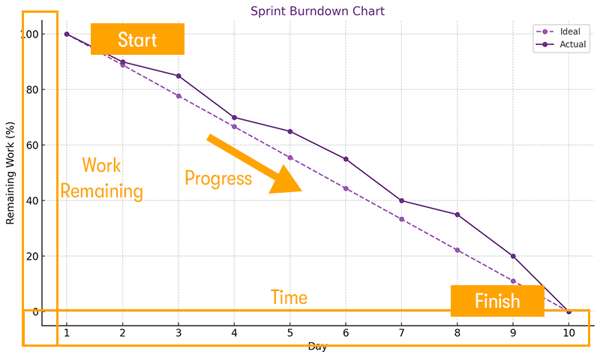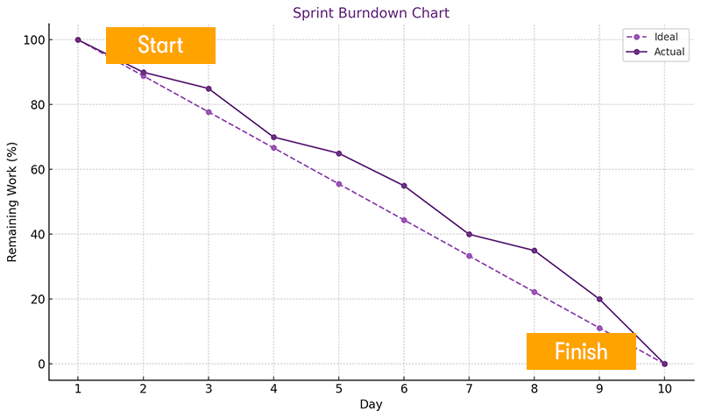
A Burndown Chart is used in Agile Scrum methodology to track the remaining work in a sprint over time.
In this project:
- The Y-axis represents remaining story points.
- The X-axis represents sprint days.
- As tasks are completed, the remaining work decreases until it reaches zero at sprint completion.
Benefits of using Burndown Chart:
- Tracks project progress in real time
- Identifies delays early
- Helps teams adjust workload
- Improves sprint planning accuracy

